Don’t Print This Page.

|  |  |  |  |
| --- | --- | --- | --- |
| Developed By | Date | Approved By | Course Type (New/Update) |
|  | 20XX-XX-XX | Wang Xiaomin | Update |
|  |  |  |  |
|  |  |  |  |
|  |  |  |  |
|  |  |  |  |
|  |  |  |  |

|  |  |  |  |
| --- | --- | --- | --- |
| Course Code | Product | Product Version | Course Issue |
|  |  |  |  |

Revision Record

IT OM Automation Tool RESTful web services design and implementationLab Guide



Huawei Technologies CO., LTD.

# Contents

Contents ii

1. Lab Environment 1

1.1 About This Course 1

1.2 Lab Envirnoment of Ansible Systems 2

1. Create a Jersey hello world JAX-RS Application 3

2.1 Introduction 3

2.1.1 About this lab 3

2.1.2 Objectives 3

2.2 Lab Setup Guide 3

2.2.1 Set Up Your Development Environment 3

2.2.2 Create a New React Native Project 3

2.2.3. Run Your React Native App on Android 3

2.3 Configuration Steps 3

2.3.1. Create New Dynamic Web Project 3

2.3.2. Add JAX-RS / Jersey Dependent JAR files 4

2.3.3.Create REST Service : 5

2.3.4. Create Web.xml configuration File 5

1. Create an annotation JAX-RS Application 8

3.1 Introduction 8

3.1.1 About this lab 8

3.1.2 Objectives 8

3.2 Configuration Steps 9

1. Create a GET method 11

4.1 Introduction 11

4.1.1 About this lab 11

4.1.2 Objectives 11

4.2 Configuration Steps 11

1. Create an UPDATE method 13

5.1 Introduction 13

5.1.1 About this lab 13

5.1.2 Objectives 13

5.2 Configuration Steps 13

1. Validation & Exception Handling 15

6.1 Introduction 15

6.1.1 About this lab 15

6.1.2 Objectives 15

6.2 Configuration Steps 15

1. MultiValuedMap and @FormParam 17

7.1 Introductions 17

7.1.1 About this lab 17

7.1.2 Objectives 17

7.2 Configuration Steps 17

1. Create a DELETE Method 20

8.1 Introduction 20

8.1.1 About this lab 20

8.1.2 Objectives 20

8.2 Configuration Steps 20

1. Matrix Parameters and Pagination 21

9.1 Introduction 21

9.1.1 About this lab 21

9.1.2 Objectives 22

9.2 Configuration Steps 22

# Lab Environment

## About This Course

* Create Java application by applying principles of RESTful Web Services using JAX-RS
* Create Web clients and Java Client for consuming RESTful Web Services
* Develop Restful services that handles failure scenarios using Exception handling mechanism provided by JAX-RS
* Apply Filters and Interceptors to RESTful Web Services
* Validate inputs supplied to a RESTful Web Services
* Apply Pagination and HATEOS in RESTful Web Services
* Create multiple versions of RESTful Web Services

## Lab Envirnoment of Java Systems

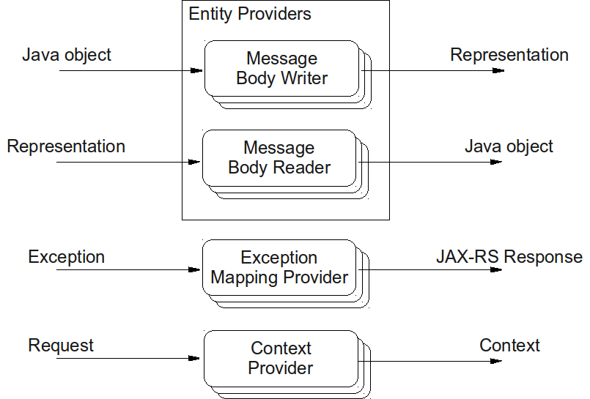

# Create a Jersey hello world JAX-RS Application



## Introduction



### About this lab

* Upon completion of this task, you will be able to:
  + Create and test a Jersey hello world JAX-RS Application.

### Objectives

* Upon completion of this task, you will be able to:
* Install Ansible
* Create user devops on all the nodes
* Setup the ssh keys and copy ssh keys for password less Authentication

## Lab Setup Guide

### Set Up Your Development Environment

### Create a New React Native Project

### Run Your React Native App on Android

## Configuration Steps

### 1. Create New Dynamic Web Project

The first step is to create a Dynamic Web Project using Eclipse IDE. Open eclipse IDE and click on **File -> New -> Project** and select Dynamic Web Project wizard from the wizard list. Now name your project as "RESTfulExample" and Click on Finish button using the wizard window as shown below.

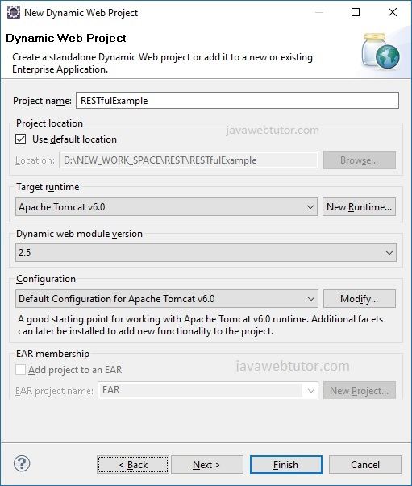

### 2. Add JAX-RS / Jersey Dependent JAR files

Add following jars in your project build path.

* asm-3.1.jar
* jersey-client-1.17.jar
* jersey-core-1.17.jar
* jersey-server-1.17.jar
* jersey-servlet-1.17.jar
* jsr311-api-1.1.1.jar

### 3 : Create REST Service :

Create a java class "HelloWorldService" in a package com.jwt.service and add following code into this.

#### HelloWorldService.java

package com.jwt.service;

import javax.ws.rs.GET;

import javax.ws.rs.Path;

import javax.ws.rs.PathParam;

import javax.ws.rs.core.Response;

@Path("/hello")

public class HelloWorldService {

@GET

@Path("/{name}")

public Response getMsg(@PathParam("name") String name) {

String output = "Welcome : " + name;

return Response.status(200).entity(output).build();

}

}

### 4. Create Web.xml configuration File

Specify Jersey framework Servlet for our application in web.xml file.In web.xml, register "com.sun.jersey.  
spi.container.servlet.ServletContainer", and puts your Jersey service folder under "init-param","com.sun.jersey.  
config.property.packages".

#### web.xml

<?xml version="1.0" encoding="UTF-8"?>

<web-app xmlns:xsi="<http://www.w3.org/2001/XMLSchema-instance>"

xmlns="<http://java.sun.com/xml/ns/javaee>"

xmlns:web="<http://java.sun.com/xml/ns/javaee/web-app_2_5.xsd>"

xsi:schemaLocation="<http://java.sun.com/xml/ns/javaee>

<http://java.sun.com/xml/ns/javaee/web-app_2_5.xsd>" id="WebApp_ID" version="2.5">

<display-name>RESTfulExample</display-name>

<servlet>

<servlet-name>jersey-serlvet</servlet-name>

<servlet-class>

com.sun.jersey.spi.container.servlet.ServletContainer

</servlet-class>

<init-param>

<param-name>com.sun.jersey.config.property.packages</param-name>

<param-value>com.jwt.service</param-value>

</init-param>

<load-on-startup>1</load-on-startup>

</servlet>

<servlet-mapping>

<servlet-name>jersey-serlvet</servlet-name>

<url-pattern>/rest/*</url-pattern>

</servlet-mapping>

</web-app>

### Directory Structure of project

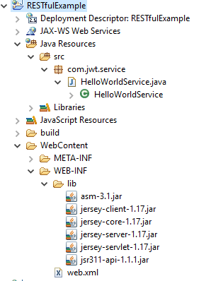

### Run the application :

Right click on project -> run as -> run on server Select Apache tomcat and click on finish as shown below.

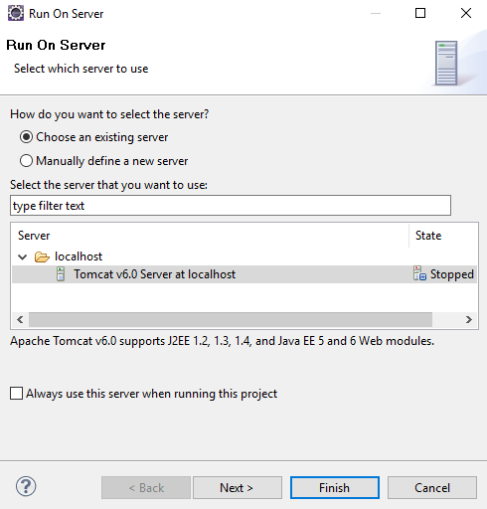

By default eclipse will open <http://localhost:8080>  
/RESTfulExample/ . As In web.xml we have specified URL pattern as /rest/* (line number 22) and in HelloWorldService.java we specified class level @path as /hello [ line number 8 ] and method level @path as {name} [ line number 1 ],So the final URL should be "<http://localhost:8080>  
/RESTfulExample/rest/hello/javawebtutor".

Test your REST service under: "<http://localhost:8080>  
/RESTfulExample/rest/hello/javawebtutor".You will get following output in browser:

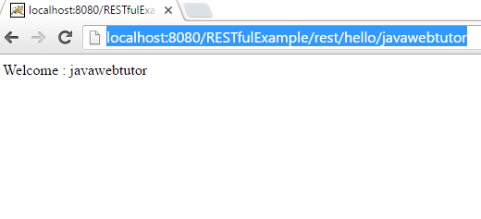

You can download the source code of the example by clicking on the Download link below.

|  |
| --- |
| Source + Lib : [Download](https://www.javawebtutor.com/code/rest/RESTfulExample.zip) |



# Create an annotation JAX-RS Application



## Introduction



### About this lab

* Upon completion of this task, you will be able to:
  + Create an annotation JAR-XS Application
  + Test an annotation JAR-XS Application

### Objectives

Create a simple JAX-RS application using annotations to define RESTful resources and methods. Test the application using a web browser or a tool like Postman.

## Configuration Steps

• **Set Up Your Project:**

* Create a new Java web project in your IDE.
* Add the necessary JAX-RS dependencies to your project. You can use Maven or manually include the JAX-RS library (e.g., Jersey).

• **Write a JAX-RS Resource Class:**

* Create a new Java class to define your JAX-RS resource. Use annotations to specify the resource path and HTTP methods.
* Example (HelloResource.java):

java

import javax.ws.rs.GET;

import javax.ws.rs.Path;

@Path("/hello")

public class HelloResource {

@GET

public String sayHello() {

return "Hello, World!";

}

}

• **Configure Servlet Container:**

* Configure your servlet container (e.g., Apache Tomcat) to deploy JAX-RS applications. This typically involves adding JAX-RS servlet mappings to web.xml or using Servlet annotations.
* Example (web.xml):

xml

<servlet>

<servlet-name>Jersey Servlet</servlet-name>

<servlet-class>org.glassfish.jersey.servlet.ServletContainer</servlet-class>

<init-param>

<param-name>jersey.config.server.provider.packages</param-name>

<param-value>your.package.name</param-value>

</init-param>

<load-on-startup>1</load-on-startup>

</servlet>

<servlet-mapping>

<servlet-name>Jersey Servlet</servlet-name>

<url-pattern>/api/*</url-pattern>

</servlet-mapping>

• **Deploy and Run the Application:**

* Deploy your application to the servlet container.
* Start the servlet container and access the application's endpoint in a web browser or using a tool like Postman.
* The endpoint URL should be http://localhost:8080/<context-path>/api/hello.

• **Test the Application:**

* Open a web browser or Postman and send a GET request to the endpoint URL (http://localhost:8080/<context-path>/api/hello).
* You should receive a response with the text "Hello, World!".

• **Experiment and Enhance:**

* Experiment with adding more JAX-RS resource classes, methods, and annotations to create a more comprehensive RESTful API.
* Test different HTTP methods (e.g., POST, PUT, DELETE) and handle request parameters and payloads as needed.

# Create a GET method



## Introduction



### About this lab

* Upon completion of this task, you will be able to:
* Create a GET Method JAR-XS Application
* Test a GET Method JAR-XS Application

### Objectives

Create a JAX-RS application with a resource that implements a GET method to retrieve data. Test the application using a web browser or a tool like Postman.

## Configuration Steps

• **Set Up Your Project:**

* Create a new Java web project in your IDE.
* Add the necessary JAX-RS dependencies to your project. You can use Maven or manually include the JAX-RS library (e.g., Jersey).

• **Write a JAX-RS Resource Class:**

* Create a new Java class to define your JAX-RS resource. Use annotations to specify the resource path and HTTP methods.
* Example (HelloResource.java):

java

import javax.ws.rs.GET;

import javax.ws.rs.Path;

import javax.ws.rs.Produces;

import javax.ws.rs.core.MediaType;

@Path("/hello")

public class HelloResource {

@GET

@Produces(MediaType.TEXT_PLAIN)

public String sayHello() {

return "Hello, World!";

}

}

• **Configure Servlet Container:**

* Configure your servlet container (e.g., Apache Tomcat) to deploy JAX-RS applications. This typically involves adding JAX-RS servlet mappings to web.xml or using Servlet annotations.
* Example (web.xml):

xml

<servlet>

<servlet-name>Jersey Servlet</servlet-name>

<servlet-class>org.glassfish.jersey.servlet.ServletContainer</servlet-class>

<init-param>

<param-name>jersey.config.server.provider.packages</param-name>

<param-value>your.package.name</param-value>

</init-param>

<load-on-startup>1</load-on-startup>

</servlet>

<servlet-mapping>

<servlet-name>Jersey Servlet</servlet-name>

<url-pattern>/api/*</url-pattern>

</servlet-mapping>

• **Deploy and Run the Application:**

* Deploy your application to the servlet container.
* Start the servlet container and access the application's endpoint in a web browser or using a tool like Postman.
* The endpoint URL should be http://localhost:8080/<context-path>/api/hello.

• **Test the Application:**

* Open a web browser or Postman and send a GET request to the endpoint URL (http://localhost:8080/<context-path>/api/hello).
* You should receive a response with the text "Hello, World!".

• **Experiment and Enhance:**

* Experiment with adding more JAX-RS resource classes, methods, and annotations to create a more comprehensive RESTful API.
* Test different response types (e.g., JSON, XML) by using different @Produces annotations.

# Create an UPDATE method



## Introduction



### About this lab

* Upon completion of this task, you will be able to:
* Create an UPDATE method in JAX-RS Application.
* Test an UPDATE method in JAX-RS Application

### Objectives

Create a JAX-RS application with a resource that implements an UPDATE method to update data. Test the application using a tool like Postman.

## Configuration Steps

**1.** • **Set Up Your Project:**

* Create a new Java web project in your IDE.
* Add the necessary JAX-RS dependencies to your project. You can use Maven or manually include the JAX-RS library (e.g., Jersey).

• **Write a JAX-RS Resource Class:**

* Create a new Java class to define your JAX-RS resource. Use annotations to specify the resource path and HTTP methods.
* Example (UserResource.java):

java

• import javax.ws.rs.PUT;

import javax.ws.rs.Path;

import javax.ws.rs.PathParam;

import javax.ws.rs.Produces;

import javax.ws.rs.core.MediaType;

@Path("/users")

public class UserResource {

@PUT

@Path("/{id}")

@Produces(MediaType.TEXT_PLAIN)

public String updateUser(@PathParam("id") int id, String newData) {

// Update user with the specified ID using the newData

return "User with ID " + id + " updated successfully.";

}

}

• **Configure Servlet Container:**

* Configure your servlet container (e.g., Apache Tomcat) to deploy JAX-RS applications. This typically involves adding JAX-RS servlet mappings to web.xml or using Servlet annotations.
* Example (web.xml):

xml

• <servlet>

<servlet-name>Jersey Servlet</servlet-name>

<servlet-class>org.glassfish.jersey.servlet.ServletContainer</servlet-class>

<init-param>

<param-name>jersey.config.server.provider.packages</param-name>

<param-value>your.package.name</param-value>

</init-param>

<load-on-startup>1</load-on-startup>

</servlet>

<servlet-mapping>

<servlet-name>Jersey Servlet</servlet-name>

<url-pattern>/api/*</url-pattern>

</servlet-mapping>

• **Deploy and Run the Application:**

* Deploy your application to the servlet container.
* Start the servlet container and access the application's endpoint in a tool like Postman.
* The endpoint URL should be http://localhost:8080/<context-path>/api/users/{id}. Replace {id} with the ID of the user to update.

• **Test the Application:**

* Use Postman or a similar tool to send a PUT request to the endpoint URL (http://localhost:8080/<context-path>/api/users/{id}).
* Include the new data for the user in the request body.
* You should receive a response indicating that the user was updated successfully.

• **Experiment and Enhance:**

* Experiment with handling different types of data and error scenarios in your updateUser method.
* Consider adding validation logic and error handling to ensure the stability and security of your application.

# Validation & Exception Handling



## Introduction



### About this lab

* Upon completion of this task, you will be able to:
  + Create a JAX-RS Application with Validation.
  + Create a JAX-RS Application with Exception Handling.

### Objectives

Create a JAX-RS application that handles resource creation with input validations and proper exception handling. Test the application using a tool like Postman.

## Configuration Steps

• **Set Up Your Project:**

* Create a new Java web project in your IDE.
* Add the necessary JAX-RS dependencies to your project. You can use Maven or manually include the JAX-RS library (e.g., Jersey).

• **Write a JAX-RS Resource Class:**

* Create a new Java class to define your JAX-RS resource. Use annotations to specify the resource path and HTTP methods.
* Implement input validations and exception handling logic in the resource methods.
* Example (UserResource.java):

java

import javax.validation.Valid;

import javax.validation.constraints.NotBlank;

import javax.ws.rs.*;

import javax.ws.rs.core.MediaType;

import javax.ws.rs.core.Response;

@Path("/users")

public class UserResource {

@POST

@Consumes(MediaType.APPLICATION_JSON)

@Produces(MediaType.APPLICATION_JSON)

public Response createUser(@Valid User user) {

if (user.getName() == null || user.getName().trim().isEmpty()) {

throw new BadRequestException("User name is required");

}

// Persist user in database or perform other actions

return Response.status(Response.Status.CREATED).entity(user).build();

}

}

• **Create a User Model:**

* Create a Java class to represent the user model with appropriate fields and annotations for validation.
* Example (User.java):

java

import javax.validation.constraints.NotBlank;

public class User {

@NotBlank(message = "Name cannot be blank")

private String name;

// Getter and setter methods

}

• **Configure Servlet Container:**

* Configure your servlet container (e.g., Apache Tomcat) to deploy JAX-RS applications. This typically involves adding JAX-RS servlet mappings to web.xml or using Servlet annotations.

• **Deploy and Run the Application:**

* Deploy your application to the servlet container.
* Start the servlet container and access the application's endpoint in a tool like Postman.

• **Test the Application:**

* Use Postman or a similar tool to send a POST request to the endpoint URL (http://localhost:8080/<context-path>/api/users).
* Include a JSON payload representing the user data in the request body.
* Test different scenarios, such as valid input, missing required fields, and invalid data, to observe how the application handles them.

• **Experiment and Enhance:**

* Experiment with adding more validations and error handling logic to your resource methods.
* Consider logging error messages and returning appropriate HTTP status codes and error responses to clients.

# MultiValuedMap and @FormParam



## Introductions



### About this lab

* Upon completion of this task, you will be able to:
* Create a JAX-RS Application with MultiValuedMap and @FormParam.
* Test a JAX-RS Application with MultiValuedMap and @FormParam

### Objectives

Create a JAX-RS application that accepts form data using @FormParam and MultiValuedMap. Test the application using a tool like Postman.

## Configuration Steps

• **Set Up Your Project:**

* Create a new Java web project in your IDE.
* Add the necessary JAX-RS dependencies to your project. You can use Maven or manually include the JAX-RS library (e.g., Jersey).

• **Write a JAX-RS Resource Class:**

* Create a new Java class to define your JAX-RS resource. Use annotations to specify the resource path and HTTP methods.
* Use @FormParam to extract form parameters from the request.
* Example (FormDataResource.java):

java

import javax.ws.rs.*;

import javax.ws.rs.core.MediaType;

import javax.ws.rs.core.MultivaluedMap;

@Path("/form")

public class FormDataResource {

@POST

@Consumes(MediaType.APPLICATION_FORM_URLENCODED)

@Produces(MediaType.TEXT_PLAIN)

public String processFormData(@FormParam("name") String name, @FormParam("email") String email) {

return "Received form data: Name = " + name + ", Email = " + email;

}

@POST

@Path("/map")

@Consumes(MediaType.APPLICATION_FORM_URLENCODED)

@Produces(MediaType.TEXT_PLAIN)

public String processFormDataMap(MultivaluedMap<String, String> formData) {

String result = "Received form data:";

for (String key : formData.keySet()) {

result += "\n" + key + " = " + formData.getFirst(key);

}

return result;

}

}

• **Configure Servlet Container:**

* Configure your servlet container (e.g., Apache Tomcat) to deploy JAX-RS applications. This typically involves adding JAX-RS servlet mappings to web.xml or using Servlet annotations.

• **Deploy and Run the Application:**

* Deploy your application to the servlet container.
* Start the servlet container and access the application's endpoints in a tool like Postman.

• **Test the Application:**

* Use Postman or a similar tool to send POST requests to the endpoint URLs:
  + http://localhost:8080/<context-path>/api/form for processFormData method.
  + http://localhost:8080/<context-path>/api/form/map for processFormDataMap method.
* Include form parameters in the request body.
* Verify that the application processes the form data correctly and returns the expected response.

• **Experiment and Enhance:**

* Experiment with handling different types of form data, such as checkboxes, radio buttons, and file uploads.
* Add validation and error handling logic to handle invalid or missing form data gracefully.
* Explore other JAX-RS annotations and features to extend the functionality of your application.

# Create a DELETE Method



## Introduction



### About this lab

* Upon completion of this task, you will be able to:
  + Create an UPDATE method in JAX-RS Application.
  + Test an UPDATE method in JAX-RS Application

### Objectives

Create a JAX-RS application with a resource that implements a DELETE method to delete resources. Test the application using a tool like Postman.



## Configuration Steps

• **Set Up Your Project:**

* Create a new Java web project in your IDE.
* Add the necessary JAX-RS dependencies to your project. You can use Maven or manually include the JAX-RS library (e.g., Jersey).

• **Write a JAX-RS Resource Class:**

* Create a new Java class to define your JAX-RS resource. Use annotations to specify the resource path and HTTP methods.
* Example (UserResource.java):

java

import javax.ws.rs.*;

@Path("/users")

public class UserResource {

@DELETE

@Path("/{id}")

public void deleteUser(@PathParam("id") String id) {

// Delete user with the specified ID

// Perform deletion operation here

}

}

• **Configure Servlet Container:**

* Configure your servlet container (e.g., Apache Tomcat) to deploy JAX-RS applications. This typically involves adding JAX-RS servlet mappings to web.xml or using Servlet annotations.

• **Deploy and Run the Application:**

* Deploy your application to the servlet container.
* Start the servlet container and access the application's endpoint in a tool like Postman.

• **Test the Application:**

* Use Postman or a similar tool to send a DELETE request to the endpoint URL (http://localhost:8080/<context-path>/api/users/{id}). Replace {id} with the ID of the user to delete.
* Verify that the application successfully deletes the user resource and returns an appropriate response.

• **Experiment and Enhance:**

* Experiment with handling different scenarios, such as deleting non-existent resources or handling errors gracefully.
* Add authentication and authorization mechanisms to restrict access to the DELETE endpoint.
* Explore other JAX-RS annotations and features to extend the functionality of your application.

# Matrix Parameters and Pagination



## Introduction

### About this lab

* Upon completion of this task, you will be able to:
  + Create and test a JAX-RS Application with Matrix Parameters and Pagination.
  + Test a JAX-RS Application with Matrix Parameters and Pagination.

### Objectives

Create a JAX-RS application with a resource that accepts matrix parameters for filtering data and implements pagination. Test the application using a tool like Postman.







## Configuration Steps

• **Set Up Your Project:**

* Create a new Java web project in your IDE.
* Add the necessary JAX-RS dependencies to your project. You can use Maven or manually include the JAX-RS library (e.g., Jersey).

• **Write a JAX-RS Resource Class:**

* Create a new Java class to define your JAX-RS resource. Use annotations to specify the resource path and HTTP methods.
* Use matrix parameters for filtering data and implementing pagination.
* Example (ProductResource.java):

java

• import javax.ws.rs.*;

import javax.ws.rs.core.MediaType;

import javax.ws.rs.core.Response;

@Path("/products")

public class ProductResource {

@GET

@Produces(MediaType.APPLICATION_JSON)

public Response getProducts(@MatrixParam("category") String category,

@MatrixParam("page") int page,

@MatrixParam("limit") int limit) {

// Implement logic to fetch products based on category and pagination

// Dummy implementation for demonstration

String response = String.format("Fetching products: category=%s, page=%d, limit=%d", category, page, limit);

return Response.ok(response).build();

}

}

• **Configure Servlet Container:**

* Configure your servlet container (e.g., Apache Tomcat) to deploy JAX-RS applications. This typically involves adding JAX-RS servlet mappings to web.xml or using Servlet annotations.

• **Deploy and Run the Application:**

* Deploy your application to the servlet container.
* Start the servlet container and access the application's endpoint in a tool like Postman.

• **Test the Application:**

* Use Postman or a similar tool to send GET requests to the endpoint URL (http://localhost:8080/<context-path>/api/products). Include matrix parameters for filtering and pagination in the request URL, e.g., ;category=electronics;page=1;limit=10.
* Verify that the application fetches products based on the specified category and pagination parameters and returns an appropriate response.

• **Experiment and Enhance:**

* Experiment with different combinations of matrix parameters to filter data and paginate results.
* Implement additional features such as sorting, searching, or advanced filtering using matrix parameters.
* Explore other JAX-RS annotations and features to extend the functionality of your application.